

**American International University- Bangladesh**

**(PROJECT)**

**Project: “*Beauty Parlor Management System*** “

SecTION: j

FACULTY: Sifat Rahman Ahona

***PROJECT BY***

1. ***MD.Rifat Hossen ID:20-41847-1***
2. ***Sharia Arfin Tanim ID:20-42096-1***
3. ***Zaid Amin Rawfin ID:20-42459-1***
4. ***MD.Taohid Hasan Anik ID:20-43028-1***
5. ***Fatama Jannat ID:18-39162-3***

|  |  |
| --- | --- |
| 01 | Introduction |
| 02 | Case Study |
| 03 | ER-DIAGRAM |
| 04 | NORMALIZATION |
| 05 | TABLE CREATE & Constraint |
| 06 | Data Insertion |
| 07 | Single Row Functions |
| 08 | Group Functions |
| 09 | Subquery |
| 10 | Joining |
| 11 | View |

# Introduction:

# Beauty parlor is a service-oriented establishment in which women receive treatment to increase their beauty. Skincare, facial make-up, hair nourishment, and model hair cutting are the most important nourishing activities of a beauty parlor. In a parlor, there is a manager who manages all the documents with details. Using pen & paper for collecting documents isn’t safe and secure.

# Hence, a management system is introduced to maintain a parlor record. It’s necessary to have a complete project on it so that the documents are safe and they can redo them whenever they want.

# It is a database management system which is helpful in the sectors of beauty parlor.

# Our main aim is to maintain records and make analyses based on reports generated.

# The system can store details of the appointment, employee, payment info, stock details, etc.

# This system is built to reduce the complexity of the system for the users handling the system.

# Case Study

# In beauty, parlor management customers may make an appointment. A customer is defined by a customer id. A customer is identified by name, gender, address, email, phone number. A customer can make one or many appointments. An appointment is defined by an appointment id. The appointment is composed of time, date. After the appointment, it will be serving time. The appointment includes one or many services. Service is defined by service id and it is composed of a service name, price, duration, material. Payment is defined by payment id which is composed of amount and date. An employee of paler is defined by an employee id. An employee is identified by name, address, phone number, status, category, gender. One employee can record many appointments, stock in, stock used, product, payment. One employee can serve one or many customers. The Product is defined by a product code. Product is composed of a name, cost, quantity, date. One product can have many stocks. Stock_in is defined by Stock_in id which is composed of quantity, date. Another hand stock_used is defined by stock_used id which is composed of quantity, date. Payment holds service and services includes payment.

Er-diagram:

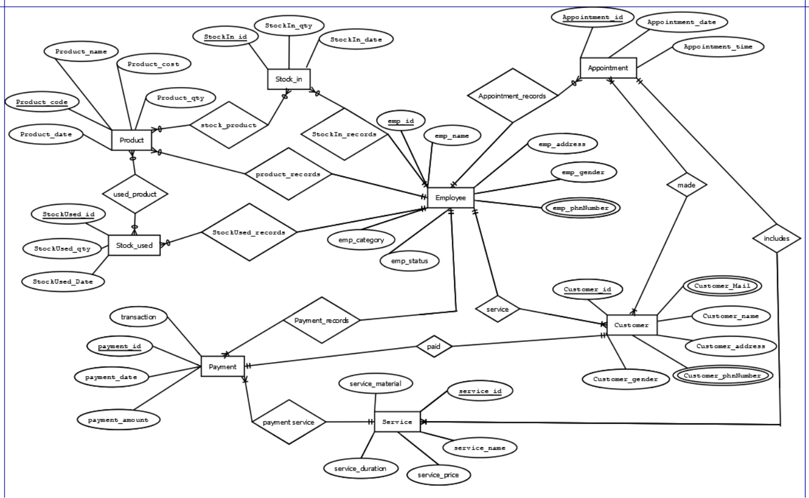

**NORMALIZATION**

**Appointment_records**(**emp_id**, emp_name, emp_address, emp_gender, emp_phnNumber, emp_category, emp_status, **appointment_id**, appointment_date, appointment_time)

**1NF**

emp_phnNumber is a multivalued attributed.

**2NF**

**emp_id**, emp_name, emp_address, emp_gender, emp_phnNumber, emp_category, emp_status.

**appointment_id**, appointment_date, appointment_time

**3NF**

**emp_id**, emp_name, emp_address, emp_gender, emp_phnNumber, e_id.

**appointment_id**, appointment_date, appointment_time, emp_id.

**e_id**, emp_category, emp_status.

**TABLE**

**emp_id**, emp_name, emp_address, emp_gender, emp_phnNumber, e_id.

**appointment_id**, appointment_date, appointment_time, emp_id.

**e_id**, emp_category, emp_status.

**Service**(**emp_id**, emp_name, emp_address, emp_gender, emp_phnNumber, emp_category, emp_status, **customer_id**, customer_name, customer_address, customer_Mail, customer_phnNumber, customer_gender)

**1NF**

emp_phnNumber, customer_Mail, customer_phnNumber is a multivalued attributed.

**2NF**

**emp_id**, emp_name, emp_address, emp_gender, emp_phnNumber, emp_category, emp_status.

**customer_id**, customer_name, customer_address, customer_Mail, customer_phnNumber, customer_gender, emp_id

**3NF**

**emp_id**, emp_name, emp_address, emp_gender, emp_phnNumber, e_id

**customer_id**, customer_name,customer_address, customer_Mail, customer_phnNumber, customer_gender, emp_id

**e_id**, emp_category, emp_status.

**TABLE**

**emp_id**, emp_name, emp_address, emp_gender, emp_phnNumber, e_id

**customer_id**, customer_name,customer_address, customer_Mail, customer_phnNumber, customer_gender, emp_id

**e_id**, emp_category, emp_status.

**Payment_records**(**emp_id**, emp_name, emp_address, emp_gender, emp_phnNumber, emp_category, emp_status, **payment_id**, payment_date, payment_amount, transaction)

**1NF**

emp_phnNumber is a multivalued attributed.

**2NF**

**emp_id**, emp_name, emp_address, emp_gender, emp_phnNumber, emp_category, emp_status.

**payment_id**, payment_date, payment_amount, transaction, emp_id.

**3NF**

**emp_id**, emp_name, emp_address, emp_gender, emp_phnNumber, e_id

**payment_id**, payment_date, payment_amount, transaction, emp_id.

**e_id**, emp_category, emp_status.

**TABLE**

**emp_id**, emp_name, emp_address, emp_gender, emp_phnNumber, e_id

**payment_id**, payment_date, payment_amount, transaction, emp_id.

**e_id**, emp_category, emp_status.

**product_records**(**emp_id**, emp_name, emp_address, emp_gender, emp_phnNumber, emp_category, emp_status, **product_code**, product_name, product_cost, product_date, product_qty)

**1NF**

emp_phnNumber is a multivalued attributed.

**2NF**

**emp_id**, emp_name, emp_address, emp_gender, emp_phnNumber, emp_category, emp_status.

**product_code**, product_name, product_cost, product_date, product_qty, emp_id.

**3NF**

**emp_id**, emp_name, emp_address, emp_gender, emp_phnNumber, e_id

**product_code**, product_name, product_cost, product_date, product_qty, emp_id.

**e_id**, emp_category, emp_status.

**TABLE**

**emp_id**, emp_name, emp_address, emp_gender, emp_phnNumber, e_id

**product_code**, product_name, product_cost, product_date, product_qty, emp_id.

**e_id**, emp_category, emp_status.

**StockIn_records**(**emp_id**, emp_name, emp_address, emp_gender, emp_phnNumber, emp_category, emp_status, **stockIn_id**, stockIn_qty, stockIn_date)

**1NF**

emp_phnNumber is a multivalued attributed.

**2NF**

**emp_id**, emp_name, emp_address, emp_gender, emp_phnNumber, emp_category, emp_status.

**stockIn_id**, stockIn_qty, stockIn_date, emp_id.

**3NF**

**emp_id**, emp_name, emp_address, emp_gender, emp_phnNumber, e_id.

**stockIn_id**, stockIn_qty, stockIn_date, emp_id.

**e_id**, emp_category, emp_status.

**TABLE**

**emp_id**, emp_name, emp_address, emp_gender, emp_phnNumber, e_id.

**stockIn_id**, stockIn_qty, stockIn_date, emp_id.

**e_id**, emp_category, emp_status.

**StockUsed_records**(**emp_id**, emp_name, emp_address, emp_gender, emp_phnNumber, emp_category, emp_status, **stockUsed_id**, stockUsed_qty, stockUsed_date)

**1NF**

emp_phnNumber is a multivalued attributed.

**2NF**

**emp_id**, emp_name, emp_address, emp_gender, emp_phnNumber, emp_category, emp_status.

**stockUsed_id**, stockUsed_qty, stockUsed_date, emp_id.

**3NF**

**emp_id**, emp_name, emp_address, emp_gender, emp_phnNumber, e_id.

**stockUsed_id**, stockUsed_qty, stockUsed_date, emp_id.

**e_id**, emp_category, emp_status.

**TABLE**

**emp_id**, emp_name, emp_address, emp_gender, emp_phnNumber, e_id.

**stockUsed_id**, stockUsed_qty, stockUsed_date, emp_id.

**e_id**, emp_category, emp_status.

**includes**(**appointment_id**, appointment_date, appointment_time, **service_id**, service_name, service_price, services_duration, service_material)

**1NF**

There is no multivalued attributed.

**2NF**

**appointment_id**, appointment_date, appointment_time.

**service_id**, service_name, service_price, services_duration, service_material, appointment_id.

**3NF**

**appointment_id**, appointment_date, appointment_time.

**service_id**, service_name, services_duration, service_material, service_price ,appointment_id.

There is no transitive dependency.

**TABLE**

**appointment_id**, appointment_date, appointment_time.

**service_id**, service_name, services_duration, service_material, service_price ,appointment_id.

**paid**(**customer_id**, customer_name, customer_address, customer_Mail, customer_phnNumber, customer_gender, **payment_id**, payment_date, payment_amount,transaction)

**1NF**

customer_Mail,customer_phnNumber is a multivalued attributed.

**2NF**

**customer_id**, customer_name, customer_address, customer_Mail, customer_phnNumber, customer_gender.

**payment_id**, payment_date, payment_amount, transaction, customer_id.

**3NF**

**customer_id**, customer_name, customer_address, customer_Mail, customer_phnNumber, customer_gender.

**payment_id**, payment_date, payment_amount, transaction, customer_id.

There is no transitive dependency.

**TABLE**

**customer_id**, customer_name, customer_address, customer_Mail, customer_phnNumber, customer_gender.

**payment_id**, payment_date, payment_amount, transaction, customer_id.

**Payment_service**(**payment_id**, payment_date, payment_amount, transaction, **service_id**, service_name, service_price, services_duration, service_material)

**1NF**

There is no multivalued attributed.

**2NF**

**payment_id**, payment_date, payment_amount, transaction, service_id.

**service_id**, service_name, service_price, services_duration, service_material.

**3NF**

**payment_id**, payment_date, payment_amount, transaction, service_id.

**service_id**, service_name, services_duration, service_material, service_price,

There is no transitive dependency.

**TABLE**

**payment_id**, payment_date, payment_amount, transaction, service_id.

**service_id**, service_name, services_duration, service_material, service_price.

**made**(**customer_id**, customer_name, customer_address, customer_Mail, customer_phnNumber, customer_gender, **appointment_id**, appointment_date, appointment_time)

**1NF**

customer_Mail,customer_phnNumber is a multivalued attributed.

**2NF**

**customer_id**, customer_name, customer_address, customer_Mail, customer_phnNumber, customer_gender.

**appointment_id**, appointment_date, appointment_time.

**ca_id**, customer_id, appointment_id.

**3NF**

**customer_id**, customer_name, customer_address, customer_Mail, customer_phnNumber, customer_gender.

**appointment_id**, appointment_date, appointment_time.

**ca_id**, customer_id, appointment_id.

There is no transitive dependency.

**TABLE**

**customer_id**, customer_name, customer_address, customer_Mail, customer_phnNumber, customer_gender.

**appointment_id**, appointment_date, appointment_time.

**ca_id**, customer_id, appointment_id.

**used_product**(**product_code**, product_name, product_cost, product_date, product_qty, **stockUsed_id**, stockUsed_qty, stockUsed_date)

**1NF**

There is no multivalued attribute.

**2NF**

**Product_code,** product_name, product_cost, product_date, product_qty.

**stockUsed_id**, stockUsed_qty, stockUsed_date.

**Pst_id**, product_code, stockUsed_id.

**3NF**

**Product_code**, product_name, product_date, product_id.

**stockUsed_id,** stockUsed_qty,stockUsed_date.

**Pst_id**,product_code, stockUsed_id.

There is no transitive dependency.

**TABLE**

**Product_code**, product_name, product_date, product_id.

**stockUsed_id,** stockUsed_qty,stockUsed_date.

**Pst_id**,product_code, stockUsed_id.

Stock_product(**product_code**, product_name, product_cost, product_date, product_qty, **stockIn_id**, stockIn_qty, stockIn_date)

**1NF**

There is no multivalued attribute.

**2NF**

**Product_code**, product_name, product_cost, product_date, product_qty.

**stockIn_id**, stockIn_qty, stockIn_date.

**Pst_id**, product_code, stockIn_id.

**3NF**

**Product_code**, product_name, product_date, product_id.

**stockIn_id**, stockIn_qty, stockIn_date.

**Pst_id**, product_code, stockIn_id.

There is no transitive dependency.

**TABLE**

**Product_code**, product_name, product_date, product_id.

**stockIn_id**, stockIn_qty, stockIn_date.

**Pst_id**, product_code, stockIn_id.

**TOTAL TABLE**

**emp_id**, emp_name, emp_address, emp_gender, emp_phnNumber, e_id.

**appointment_id**, appointment_date, appointment_time, emp_id.

**e_id**, emp_category, emp_status.

**~~emp_id~~**~~, emp_name, emp_address, emp_gender, emp_phnNumber, e_id~~

**customer_id**, customer_name, customer_address, customer_Mail, customer_phnNumber, customer_gender, emp_id

**~~e_id~~**~~, emp_category, emp_status.~~

**~~emp_id~~**~~, emp_name, emp_address, emp_gender, emp_phnNumber, e_id~~

**payment_id**, payment_date, payment_amount, transaction, emp_id.

**~~e_id~~**~~, emp_category, emp_status.~~

**~~emp_id~~**~~, emp_name, emp_address, emp_gender, emp_phnNumber, e_id~~

**product_code**, product_name, product_cost, product_date, product_qty, emp_id.

**~~e_id~~**~~, emp_category, emp_status.~~

**~~emp_id~~**~~, emp_name, emp_address, emp_gender, emp_phnNumber, e_id~~

**stockIn_id**, stockIn_qty, stockIn_date, emp_id.

**~~e_id~~**~~, emp_category, emp_status.~~

**~~emp_id~~**~~, emp_name, emp_address, emp_gender, emp_phnNumber, e_id.~~

**stockUsed_id**, stockUsed_qty, stockUsed_date, emp_id.

**~~e_id~~**~~, emp_category, emp_status.~~

**~~appointment_id~~**~~, appointment_date, appointment_time.~~

**service_id**, service_name, service_duration, service_material, service_price, appointment_id**.**

**~~customer_id~~**~~, customer_name, customer_address, customer_Mail, customer_phnNumber, customer_gender.~~

**payment_id**, payment_date, payment_amount, transaction, customer_id.

**payment_id**, payment_date, payment_amount, transaction, service_id.

**~~service_id~~**~~, service_name, services_duration, service_material, service_price.~~

**~~customer_id~~**~~, customer_name, customer_address, customer_Mail, customer_phnNumber, customer_gender.~~

**~~appointment_id~~**~~, appointment_date, appointment_time.~~

**ca_id**, customer_id, appointment_id.

**~~Product_code~~**~~, product_name, product_date, product_id.~~

**~~stockUsed_id,~~** ~~stockUsed_qty,stockUsed_date.~~

**Pst_id**,product_code, stockUsed_id.

**~~Product_code~~**~~, product_name, product_date, product_id.~~

**~~stockIn_id~~**~~, stockIn_qty, stockIn_date.~~

**Pst_id**, product_code, stockIn_id.

**Final TABLE**

1. [Employee_Info]

**emp_id**, emp_name, emp_address, emp_gender, emp_phnNumber, e_id.

1. [Appointment_info]

**appointment_id**, appointment_date, appointment_time, emp_id.

1. [Employee_category]

**e_id**, emp_category, emp_status.

1. [Customer_Info]

**customer_id**, customer_name, customer_address, customer_Mail, customer_phnNumber, customer_gender, emp_id

1. [Payment_info]

**payment_id**, payment_date, payment_amount, transaction, emp_id.

1. [Product_info]

Product_code, product_name, product_cost, product_date, product_qty, emp_id.

1. [Stock_In]

**stockIn_id**, stockIn_qty, stockIn_date, emp_id.

1. [Stock_Used]

**stockUsed_id**, stockUsed_qty, stockUsed_date, emp_id.

1. [Service_info]

**service_id**, service_name, services_duration, service_material, service_price, appointment_id.

1. [Customer_payment]

**payment_id**, payment_date, payment_amount, transaction, customer_id.

1. [Service_Payment]

**payment_id**, payment_date, payment_amount, transaction, service_id.

1. [Ca_Id]

**ca_id**, customer_id, appointment_id.

1. [Pst_Used]

**Pst_id**, product_code, stockUsed_id.

1. [Pst_In]

**Pst_id**, product_code, stockIn_id.

**TABLE CREATE**

1. CREATE TABLE Employee_category

(

e_id number(5),

emp_category varchar2(50),

emp_status varchar2(50),

PRIMARY KEY (e_id)

);

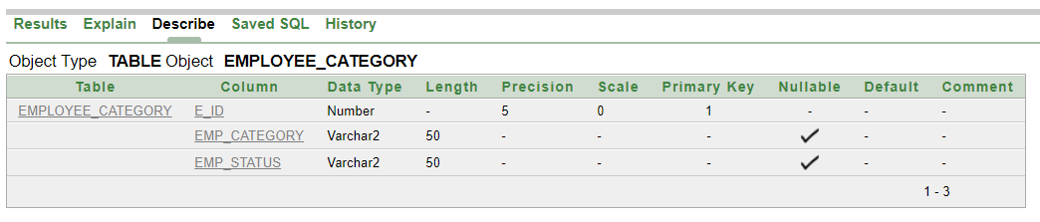

2. CREATE TABLE Employee_Info

(

emp_id number(6),

emp_name varchar2 (20) NOT NULL,

emp_address varchar2 (20),

emp_gender varchar2 (6),

emp_phnNumber varchar2 (11) unique,

e_id number(3),

PRIMARY KEY (emp_id) );

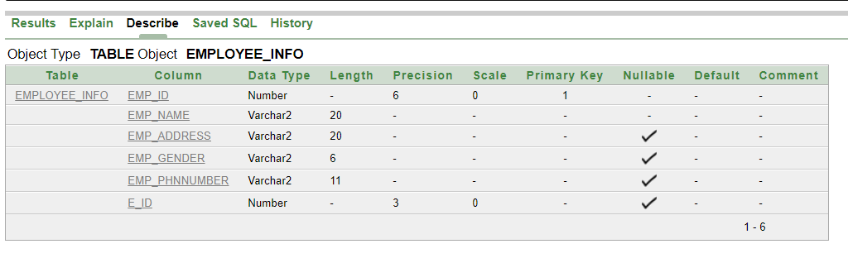

3. CREATE TABLE Appointment_info

(

appointment_id number(6),

appointment_date date not null,

appointment_time varchar2(10) not null,

emp_id number(6),

PRIMARY KEY (appointment_id)

);

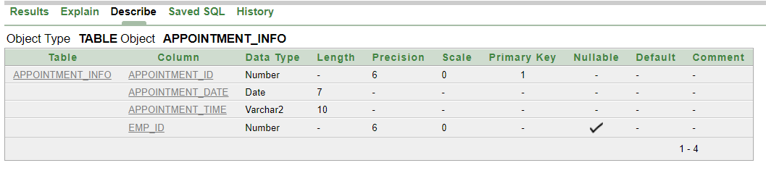

4. CREATE TABLE Customer_Info

(

customer_id number(6),

customer_name varchar2(20) not null,

customer_address varchar2(50),

customer_mail varchar2(30) unique,

customer_phnNumber varchar2(11) unique,

customer_gender varchar2(6),

emp_id number(6),

PRIMARY KEY (customer_id)

);

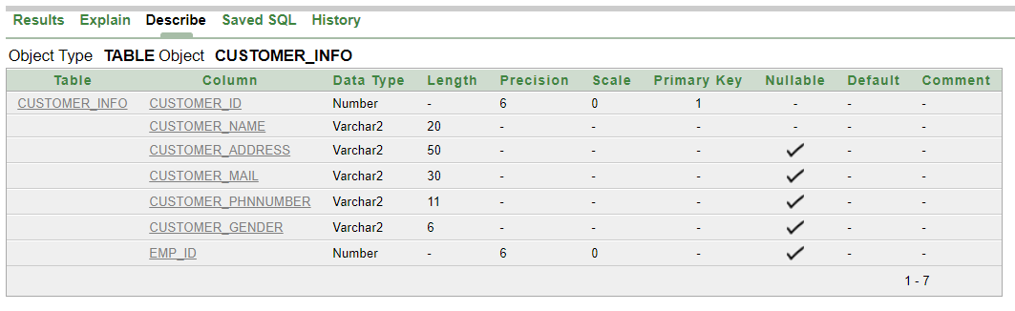

5. CREATE TABLE Payment_info

(

payment_id number(6),

payment_date date,

payment_amount number(5) not null,

transaction varchar2(15) unique,

emp_id number(6),

PRIMARY KEY (payment_id) );

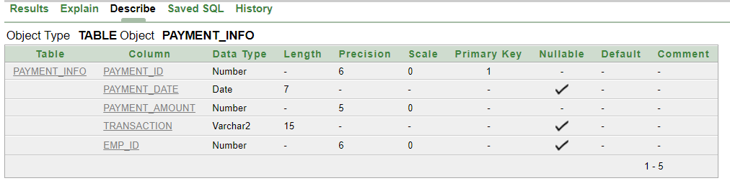

6. CREATE TABLE Product_info

(

product_code number(6),

product_name varchar2(15) not null,

product_cost number(5),

product_date date,

product_qty number(5),

emp_id number(6),

PRIMARY KEY (product_code)

);

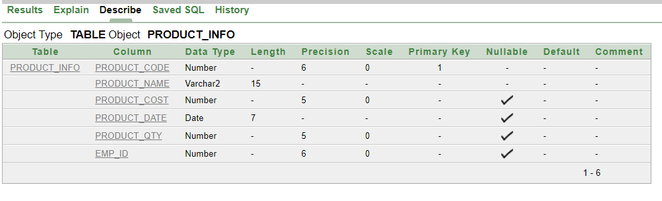

7. CREATE TABLE Stock_in

(

stockIn_id number(6),

stockIn_qty varchar2(10),

stockIn_date date,

emp_id number(6),

PRIMARY KEY (stockIn_id)

);

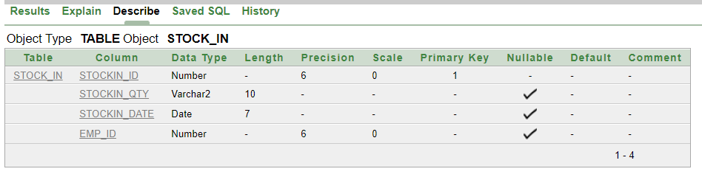

8. CREATE TABLE Stock_Used

(

stockUsed_id number(6),

stkUsed_qty varchar2(10),

stkUsed_date date,

emp_id number(6),

PRIMARY KEY (stockUsed_id)

);

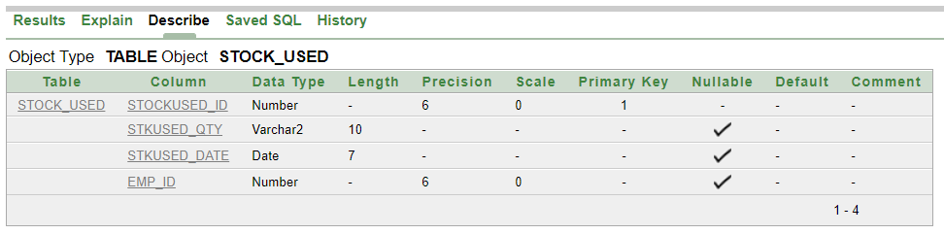

9. CREATE TABLE Service_info

(

service_id number(6),

service_name varchar2(10),

service_duration varchar2(10),

service_material varchar2(10),

service_price number(5),

appointment_id number(6),

PRIMARY KEY (service_id)

);

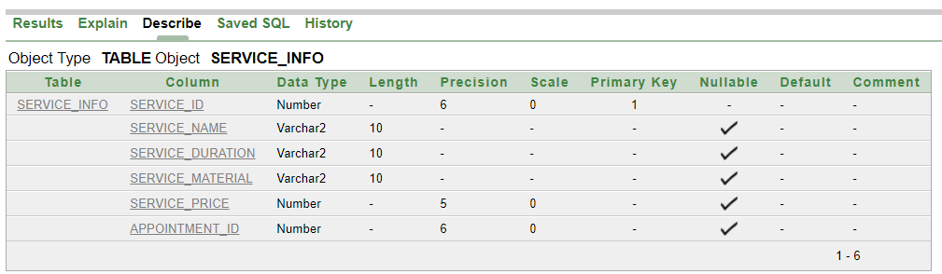

10. CREATE TABLE Customer_Payment

(

payment_id number(6),

payment_date date,

payment_amount number(5),

transaction varchar2(15) unique,

customer_id number(6),

PRIMARY KEY (payment_id)

);

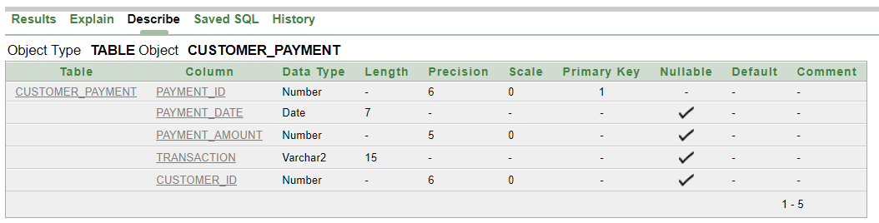

11. CREATE TABLE Service_Payment

(

payment_id number(6),

payment_date date,

payment_amount number(5),

transaction varchar(15) unique,

service_id number(6),

PRIMARY KEY (payment_id)

);

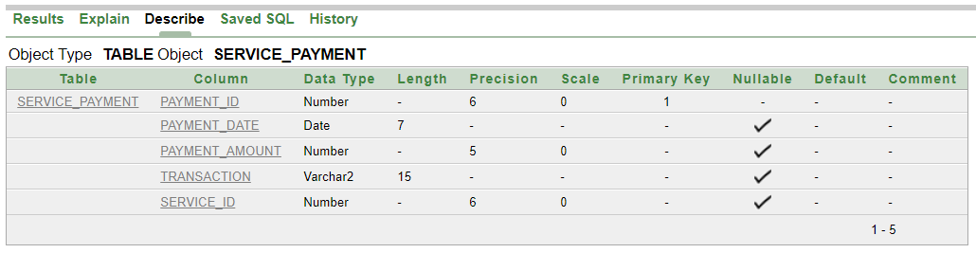

12. CREATE TABLE Ca_Id

(

ca_id number(6),

customer_id number(6),

appointment_id number(6),

PRIMARY KEY (ca_id)

);

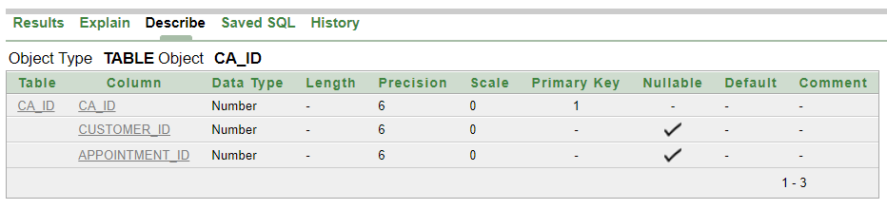

13. CREATE TABLE Pst_Used

(

pst_id number(6),

product_code number(6),

stockUsed_id number(6),

PRIMARY KEY (pst_id)

);

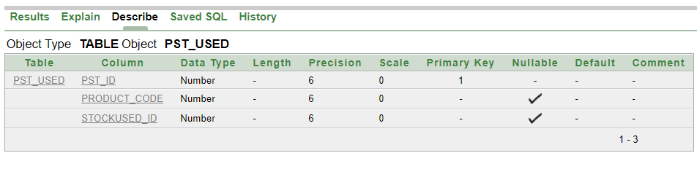

14. CREATE TABLE Pst_In

(

pst_id number(6),

product_code number(6),

stockIn_id number(6),

PRIMARY KEY (pst_id)

);

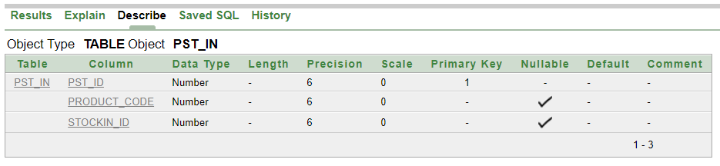

**Data Insertion**

**(Employee_category)**

INSERT INTO Employee_category(e_id,emp_category,emp_status) VALUES(101,'High Tier','Manager');

INSERT INTO Employee_category(e_id,emp_category,emp_status) VALUES(102,'High Tier','Manager');

INSERT INTO Employee_category(e_id,emp_category,emp_status) VALUES(103,'Mid Tier','Hairstylist');

INSERT INTO Employee_category(e_id,emp_category,emp_status) VALUES(104,'Mid Tier','Hairstylist');

INSERT INTO Employee_category(e_id,emp_category,emp_status) VALUES(105,'Mid Tier','Hairstylist');

INSERT INTO Employee_category(e_id,emp_category,emp_status) VALUES(106,'Mid Tier','Hairstylist');

INSERT INTO Employee_category(e_id,emp_category,emp_status) VALUES(107,'Mid Tier','Manicurist');

INSERT INTO Employee_category(e_id,emp_category,emp_status) VALUES(108,'Mid Tier','Manicurist');

INSERT INTO Employee_category(e_id,emp_category,emp_status) VALUES(109,'Mid Tier','Massage Therapist');

INSERT INTO Employee_category(e_id,emp_category,emp_status) VALUES(110,'Low Tier',' Cleaner');

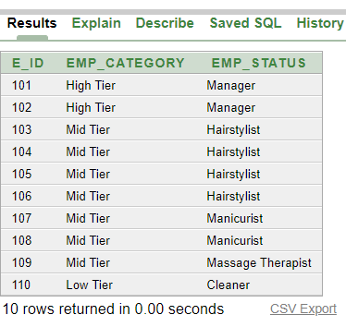

**(Employee_Info)**

INSERT INTO Employee_Info(emp_id,emp_name,emp_address,emp_gender,emp_phnNumber,e_id) VALUES(20421,'Sharia Arfin Tanim','Chattagram','Male','01815069120',101);

INSERT INTO Employee_Info(emp_id,emp_name,emp_address,emp_gender,emp_phnNumber,e_id) VALUES(20422,'Fatama Jannat ','Rangpur','Female','01815069121',102);

INSERT INTO Employee_Info(emp_id,emp_name,emp_address,emp_gender,emp_phnNumber,e_id) VALUES(20423,'Auditi Roy','Dhaka','Female','01815069122',103);

INSERT INTO Employee_Info(emp_id,emp_name,emp_address,emp_gender,emp_phnNumber,e_id) VALUES(20424,'Tanim Hasan','Feni','Male','01815069123',104);

INSERT INTO Employee_Info(emp_id,emp_name,emp_address,emp_gender,emp_phnNumber,e_id) VALUES(20425,'Anik Hasan','Saidpur','Male','01815069124',105);

INSERT INTO Employee_Info(emp_id,emp_name,emp_address,emp_gender,emp_phnNumber,e_id) VALUES(20426,'Zerin Tasnim','Barisal','Female','01815069125',106);

INSERT INTO Employee_Info(emp_id,emp_name,emp_address,emp_gender,emp_phnNumber,e_id) VALUES(20427,'Zara Khan','Syhelt','Female','01815069126',107);

INSERT INTO Employee_Info(emp_id,emp_name,emp_address,emp_gender,emp_phnNumber,e_id) VALUES(20428,'Rifat Hossian','Dhaka','Male','01815069127',108);

INSERT INTO Employee_Info(emp_id,emp_name,emp_address,emp_gender,emp_phnNumber,e_id) VALUES(20429,'Zahid Hasan','Dhaka','Male','01815069128',109);

INSERT INTO Employee_Info(emp_id,emp_name,emp_address,emp_gender,emp_phnNumber,e_id) VALUES(20430,'Nazmul Hasan','Chattagram','Male','01815069129',110);

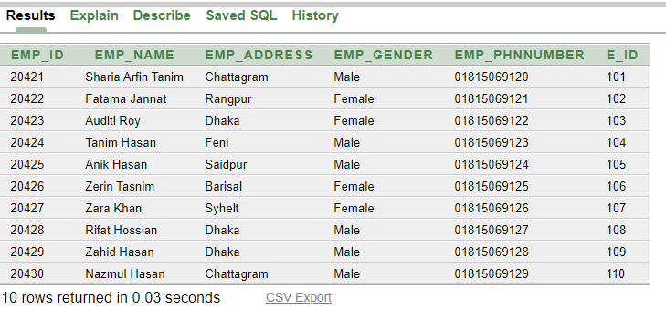

**(Appointment_info)**

INSERT INTO Appointment_info(appointment_id,appointment_date,appointment_time,emp_id) VALUES(10101,'1-JAN-20','12:00 PM',20421);

INSERT INTO Appointment_info(appointment_id,appointment_date,appointment_time,emp_id) VALUES(10102,'1-JAN-20','1:00 PM',20422);

INSERT INTO Appointment_info(appointment_id,appointment_date,appointment_time,emp_id) VALUES(10103,'2-JAN-20','2:00 PM',20423);

INSERT INTO Appointment_info(appointment_id,appointment_date,appointment_time,emp_id) VALUES(10104,'2-JAN-20','11:00 AM',20424);

INSERT INTO Appointment_info(appointment_id,appointment_date,appointment_time,emp_id) VALUES(10105,'1-JAN-20','10:00 AM',20425);

INSERT INTO Appointment_info(appointment_id,appointment_date,appointment_time,emp_id) VALUES(10106,'3-JAN-20','12:30 PM',20426);

INSERT INTO Appointment_info(appointment_id,appointment_date,appointment_time,emp_id) VALUES(10107,'4-JAN-20','2:30 PM',20427);

INSERT INTO Appointment_info(appointment_id,appointment_date,appointment_time,emp_id) VALUES(10108,'3-JAN-20','3:00 PM',20428);

INSERT INTO Appointment_info(appointment_id,appointment_date,appointment_time,emp_id) VALUES(10109,'2-JAN-20','3:30 PM',20429);

INSERT INTO Appointment_info(appointment_id,appointment_date,appointment_time,emp_id) VALUES(10110,'1-JAN-20','4:00 PM',20430);

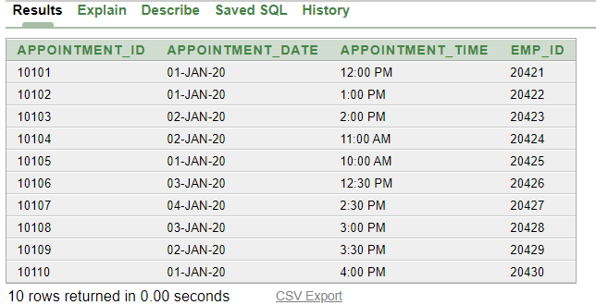

**(Customer_Info)**

INSERT INTO Customer_Info(customer_id,customer_name,customer_address,customer_mail,customer_phnNumber,customer_gender,emp_id) VALUES(3011,'Rafsan Uddin','Chattagram','rafsan@gmail.com','01815934431','Male',20421);

INSERT INTO Customer_Info(customer_id,customer_name,customer_address,customer_mail,customer_phnNumber,customer_gender,emp_id) VALUES(3012,'Anik Sen','Dhaka','aniksen@gmail.com','01815934432','Male',20422);

INSERT INTO Customer_Info(customer_id,customer_name,customer_address,customer_mail,customer_phnNumber,customer_gender,emp_id) VALUES(3013,'Rafsan Khan','Dhaka','rafsankhan@gmail.com','01815934433','Male',20423);

INSERT INTO Customer_Info(customer_id,customer_name,customer_address,customer_mail,customer_phnNumber,customer_gender,emp_id) VALUES(3014,'Shamim Uddin','Chattagram','Shamim@gmail.com','01815934434','Male',20424);

INSERT INTO Customer_Info(customer_id,customer_name,customer_address,customer_mail,customer_phnNumber,customer_gender,emp_id) VALUES(3015,'Rifat Khan','Rangpur','rifat01@gmail.com','01815934435','Male',20425);

INSERT INTO Customer_Info(customer_id,customer_name,customer_address,customer_mail,customer_phnNumber,customer_gender,emp_id) VALUES(3016,'Sharia Arfin Tanim','Dhaka','arfin@gmail.com','01815934436','Male',20426);

INSERT INTO Customer_Info(customer_id,customer_name,customer_address,customer_mail,customer_phnNumber,customer_gender,emp_id) VALUES(3017,'Tarek Hasan','Chattagram','tarek@gmail.com','01815934437','Male',20427);

INSERT INTO Customer_Info(customer_id,customer_name,customer_address,customer_mail,customer_phnNumber,customer_gender,emp_id) VALUES(3018,'Mehedi Hasan','Chattagram','mehedi@gmail.com','01815934438','Male',20428);

INSERT INTO Customer_Info(customer_id,customer_name,customer_address,customer_mail,customer_phnNumber,customer_gender,emp_id) VALUES(3019,'Ador Rahaman','Rangpur','ador02@gmail.com','01815934439','Male',20429);

INSERT INTO Customer_Info(customer_id,customer_name,customer_address,customer_mail,customer_phnNumber,customer_gender,emp_id) VALUES(3020,'Zahid Hasan','Chattagram','zahid@gmail.com','01815934444','Male',20430);

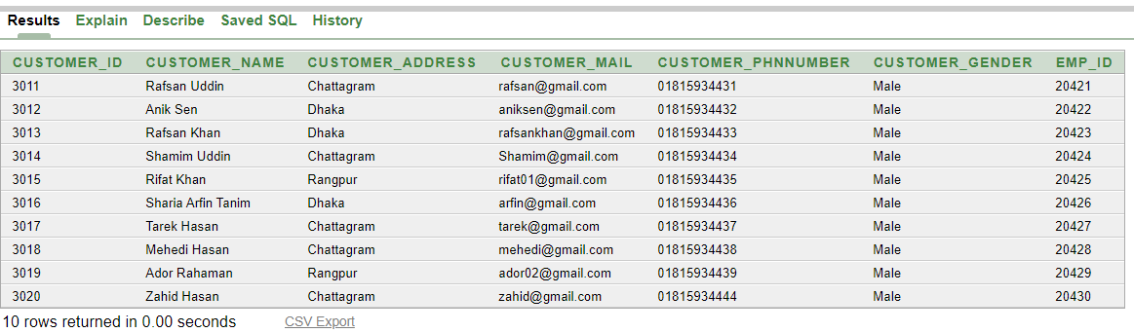

**(Payment_info)**

INSERT INTO Payment_info(payment_id,payment_date,payment_amount,transaction, emp_id) VALUES(9021,'1-JAN-20',3000,'xxx-yyy-000',20421);

INSERT INTO Payment_info(payment_id,payment_date,payment_amount,transaction, emp_id) VALUES(9022,'1-JAN-20',4000,'xxx-yyy-001',20422);

INSERT INTO Payment_info(payment_id,payment_date,payment_amount,transaction, emp_id) VALUES(9023,'2-JAN-20',5000,'xxx-yyy-002',20423);

INSERT INTO Payment_info(payment_id,payment_date,payment_amount,transaction, emp_id) VALUES(9024,'2-JAN-20',3500,'xxx-yyy-003',20424);

INSERT INTO Payment_info(payment_id,payment_date,payment_amount,transaction, emp_id) VALUES(9025,'1-JAN-20',3800,'xxx-yyy-004',20425);

INSERT INTO Payment_info(payment_id,payment_date,payment_amount,transaction, emp_id) VALUES(9026,'3-JAN-20',3700,'xxx-yyy-005',20426);

INSERT INTO Payment_info(payment_id,payment_date,payment_amount,transaction, emp_id) VALUES(9027,'4-JAN-20',4000,'xxx-yyy-006',20427);

INSERT INTO Payment_info(payment_id,payment_date,payment_amount,transaction, emp_id) VALUES(9028,'3-JAN-20',4500,'xxx-yyy-007',20428);

INSERT INTO Payment_info(payment_id,payment_date,payment_amount,transaction, emp_id) VALUES(9029,'2-JAN-20',4800,'xxx-yyy-008',20429);

INSERT INTO Payment_info(payment_id,payment_date,payment_amount,transaction, emp_id) VALUES(9030,'1-JAN-20',2000,'xxx-yyy-009',20430);

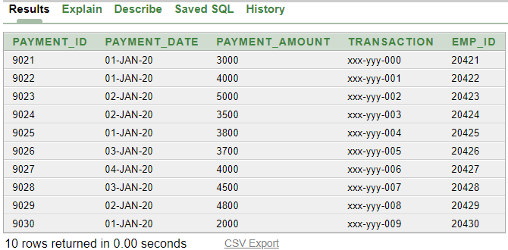

**(Product_info)**

INSERT INTO Product_info(product_code,product_name,product_cost,product_date,product_qty, emp_id) VALUES(111111,'Shampoos',300,'1-JUL-2021',15,20421);

INSERT INTO Product_info(product_code,product_name,product_cost,product_date,product_qty, emp_id) VALUES(111112,'Hair Dyes',3000,'12-JUNE-2021',25,20422);

INSERT INTO Product_info(product_code,product_name,product_cost,product_date,product_qty, emp_id) VALUES(111113,'Lighteners',500,'13-JUL-2021',14,20423);

INSERT INTO Product_info(product_code,product_name,product_cost,product_date,product_qty, emp_id) VALUES(111114,'Haircolor',5000,'14-MAY-2021',19,20424);

INSERT INTO Product_info(product_code,product_name,product_cost,product_date,product_qty, emp_id) VALUES(111115,'Hairstyling',4000,'15-MAY-2021',20,20425);

INSERT INTO Product_info(product_code,product_name,product_cost,product_date,product_qty, emp_id) VALUES(111116,'Shampoos',600,'19-APRIL-2021',22,20426);

INSERT INTO Product_info(product_code,product_name,product_cost,product_date,product_qty, emp_id) VALUES(111117,'Manicures',2000,'21-JAN-2021',25,20427);

INSERT INTO Product_info(product_code,product_name,product_cost,product_date,product_qty, emp_id) VALUES(111118,'Moisturizing',3500,'27-JUNE-2021',35,20428);

INSERT INTO Product_info(product_code,product_name,product_cost,product_date,product_qty, emp_id) VALUES(111119,'Exfoliation',3800,'25-JUL-2021',12,20429);

INSERT INTO Product_info(product_code,product_name,product_cost,product_date,product_qty, emp_id) VALUES(111120,'Moisturizing',2500,'30-JUL-2021',30,20430);

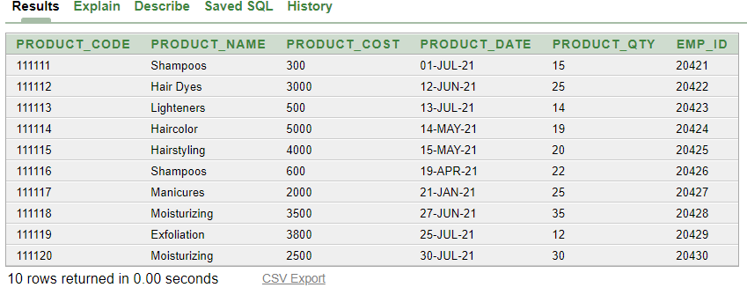

**(Stock_in)**

INSERT INTO Stock_in(stockIn_id,stockIn_qty,stockIn_date,emp_id) VALUES(90901,'11','12-JUL-2020',20421);

INSERT INTO Stock_in(stockIn_id,stockIn_qty,stockIn_date,emp_id) VALUES(90902,'20','14-JUNE-2020',20422);

INSERT INTO Stock_in(stockIn_id,stockIn_qty,stockIn_date,emp_id) VALUES(90903,'15','15-JUNE-2020',20423);

INSERT INTO Stock_in(stockIn_id,stockIn_qty,stockIn_date,emp_id) VALUES(90904,'18','16-MAY-2020',20424);

INSERT INTO Stock_in(stockIn_id,stockIn_qty,stockIn_date,emp_id) VALUES(90905,'15','17-MAY-2020',20425);

INSERT INTO Stock_in(stockIn_id,stockIn_qty,stockIn_date,emp_id) VALUES(90906,'17','19-JUL-2020',20426);

INSERT INTO Stock_in(stockIn_id,stockIn_qty,stockIn_date,emp_id) VALUES(90907,'20','20-JUL-2020',20427);

INSERT INTO Stock_in(stockIn_id,stockIn_qty,stockIn_date,emp_id) VALUES(90908,'14','21-JUNE-2020',20428);

INSERT INTO Stock_in(stockIn_id,stockIn_qty,stockIn_date,emp_id) VALUES(90909,'19','25-JUNE-2020',20429);

INSERT INTO Stock_in(stockIn_id,stockIn_qty,stockIn_date,emp_id) VALUES(90910,'15','27-JUL-2020',20430);

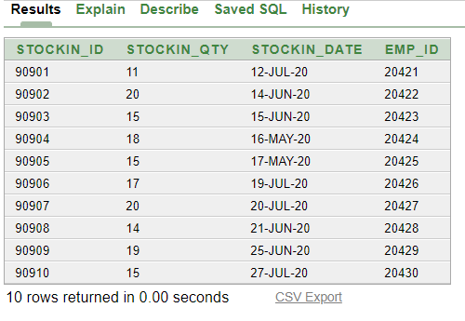

**(Stock_Used)**

INSERT INTO Stock_Used(stockUsed_id,stkUsed_qty,stkUsed_date,emp_id) VALUES(80801,'5','28-JAN-2020',20421);

INSERT INTO Stock_Used(stockUsed_id,stkUsed_qty,stkUsed_date,emp_id) VALUES(80802,'6','25-FEB-2020',20422);

INSERT INTO Stock_Used(stockUsed_id,stkUsed_qty,stkUsed_date,emp_id) VALUES(80803,'7','26-MARCH-2020',20423);

INSERT INTO Stock_Used(stockUsed_id,stkUsed_qty,stkUsed_date,emp_id) VALUES(80804,'8','27-FEB-2020',20424);

INSERT INTO Stock_Used(stockUsed_id,stkUsed_qty,stkUsed_date,emp_id) VALUES(80805,'5','20-JAN-2020',20425);

INSERT INTO Stock_Used(stockUsed_id,stkUsed_qty,stkUsed_date,emp_id) VALUES(80806,'8','25-JUNE-2020',20426);

INSERT INTO Stock_Used(stockUsed_id,stkUsed_qty,stkUsed_date,emp_id) VALUES(80807,'7','23-JULY-2020',20427);

INSERT INTO Stock_Used(stockUsed_id,stkUsed_qty,stkUsed_date,emp_id) VALUES(80808,'6','29-MAY-2020',20428);

INSERT INTO Stock_Used(stockUsed_id,stkUsed_qty,stkUsed_date,emp_id) VALUES(80809,'8','30-MAY-2020',20429);

INSERT INTO Stock_Used(stockUsed_id,stkUsed_qty,stkUsed_date,emp_id) VALUES(80810,'8','18-JAN-2020',20430);

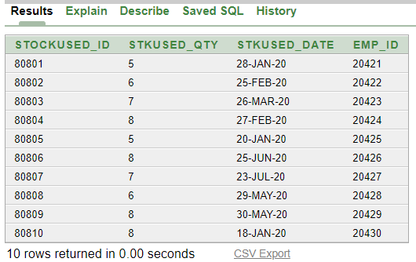

**(Service_info)**

INSERT INTO Service_info(service_id,service_name,service_duration,service_material,service_price,appointment_id) VALUES(110220,'Haircolor','2 hour','color',600,10101);

INSERT INTO Service_info(service_id,service_name,service_duration,service_price,appointment_id) VALUES(110221,'Haircuts','2 hour',100,10102);

INSERT INTO Service_info(service_id,service_name,service_duration,service_material,service_price,appointment_id) VALUES(110222,'Condition','1 hour','Dryerchair',300,10103);

INSERT INTO Service_info(service_id,service_name,service_duration,service_material,service_price,appointment_id) VALUES(110223,'BasFacial','2 hour','Dryerchair',500,10104);

INSERT INTO Service_info(service_id,service_name,service_duration,service_material,service_price,appointment_id) VALUES(110224,'DelxFacial','3 hour','Dryerchair',700,10105);

INSERT INTO Service_info(service_id,service_name,service_duration,service_material,service_price,appointment_id) VALUES(110225,'AcneFacial','1 hour','Dryerchair',800,10106);

INSERT INTO Service_info(service_id,service_name,service_duration,service_material,service_price,appointment_id) VALUES(110226,'Makeup','3 hour','Makeup',6000,10107);

INSERT INTO Service_info(service_id,service_name,service_duration,service_material,service_price,appointment_id) VALUES(110227,'Haircolor','2 hour','color',600,10108);

INSERT INTO Service_info(service_id,service_name,service_duration,service_price,appointment_id) VALUES(110228,'Haircuts','2 hour',200,10109);

INSERT INTO Service_info(service_id,service_name,service_duration,service_material,service_price,appointment_id) VALUES(110229,'Wedding','5 hour','Makeup',9000,10110);

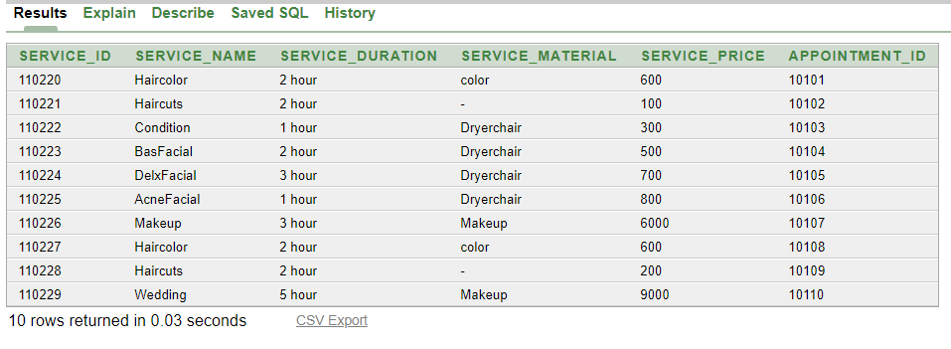

**(Customer_Payment)**

INSERT INTO Customer_Payment(payment_id,payment_date,payment_amount,transaction,customer_id) VALUES(9021,'1-JAN-20',3000,'xxx-yyy-000',3011);

INSERT INTO Customer_Payment(payment_id,payment_date,payment_amount,transaction,customer_id) VALUES(9022,'1-JAN-20',4000,'xxx-yyy-001',3012);

INSERT INTO Customer_Payment(payment_id,payment_date,payment_amount,transaction,customer_id) VALUES(9023,'2-JAN-20',5000,'xxx-yyy-002',3013);

INSERT INTO Customer_Payment(payment_id,payment_date,payment_amount,transaction,customer_id) VALUES(9024,'2-JAN-20',3500,'xxx-yyy-003',3014);

INSERT INTO Customer_Payment(payment_id,payment_date,payment_amount,transaction,customer_id) VALUES(9025,'1-JAN-20',3800,'xxx-yyy-004',3015);

INSERT INTO Customer_Payment(payment_id,payment_date,payment_amount,transaction,customer_id) VALUES(9026,'3-JAN-20',3700,'xxx-yyy-005',3016);

INSERT INTO Customer_Payment(payment_id,payment_date,payment_amount,transaction,customer_id) VALUES(9027,'4-JAN-20',4000,'xxx-yyy-006',3017);

INSERT INTO Customer_Payment(payment_id,payment_date,payment_amount,transaction,customer_id) VALUES(9028,'3-JAN-20',4500,'xxx-yyy-007',3018);

INSERT INTO Customer_Payment(payment_id,payment_date,payment_amount,transaction,customer_id) VALUES(9029,'2-JAN-20',4800,'xxx-yyy-008',3019);

INSERT INTO Customer_Payment(payment_id,payment_date,payment_amount,transaction,customer_id) VALUES(9030,'1-JAN-20',2000,'xxx-yyy-009',3020);

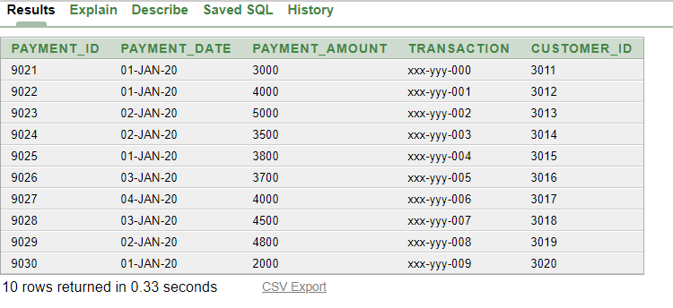

**(Service_Payment)**

INSERT INTO Service_Payment(payment_id,payment_date,payment_amount,transaction,service_id) VALUES(9021,'1-JAN-20',3000,'xxx-yyy-000',110220);

INSERT INTO Service_Payment(payment_id,payment_date,payment_amount,transaction,service_id) VALUES(9022,'1-JAN-20',4000,'xxx-yyy-001',110221);

INSERT INTO Service_Payment(payment_id,payment_date,payment_amount,transaction,service_id) VALUES(9023,'2-JAN-20',5000,'xxx-yyy-002',110222);

INSERT INTO Service_Payment(payment_id,payment_date,payment_amount,transaction,service_id) VALUES(9024,'2-JAN-20',3500,'xxx-yyy-003',110223);

INSERT INTO Service_Payment(payment_id,payment_date,payment_amount,transaction,service_id) VALUES(9025,'1-JAN-20',3800,'xxx-yyy-004',110224);

INSERT INTO Service_Payment(payment_id,payment_date,payment_amount,transaction,service_id) VALUES(9026,'3-JAN-20',3700,'xxx-yyy-005',110225);

INSERT INTO Service_Payment(payment_id,payment_date,payment_amount,transaction,service_id) VALUES(9027,'4-JAN-20',4000,'xxx-yyy-006',110226);

INSERT INTO Service_Payment(payment_id,payment_date,payment_amount,transaction,service_id) VALUES(9028,'3-JAN-20',4500,'xxx-yyy-007',110227);

INSERT INTO Service_Payment(payment_id,payment_date,payment_amount,transaction,service_id) VALUES(9029,'2-JAN-20',4800,'xxx-yyy-008',110228);

INSERT INTO Service_Payment(payment_id,payment_date,payment_amount,transaction,service_id) VALUES(9030,'1-JAN-20',2000,'xxx-yyy-009',110229);

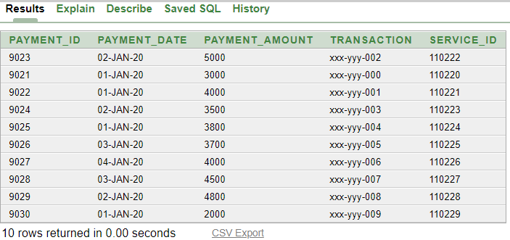

**(Ca_Id)**

INSERT INTO Ca_Id(ca_id,customer_id,appointment_id) VALUES(21,3011,10101);

INSERT INTO Ca_Id(ca_id,customer_id,appointment_id) VALUES(22,3012,10102);

INSERT INTO Ca_Id(ca_id,customer_id,appointment_id) VALUES(23,3013,10103);

INSERT INTO Ca_Id(ca_id,customer_id,appointment_id) VALUES(24,3014,10104);

INSERT INTO Ca_Id(ca_id,customer_id,appointment_id) VALUES(25,3015,10105);

INSERT INTO Ca_Id(ca_id,customer_id,appointment_id) VALUES(26,3016,10106);

INSERT INTO Ca_Id(ca_id,customer_id,appointment_id) VALUES(27,3017,10107);

INSERT INTO Ca_Id(ca_id,customer_id,appointment_id) VALUES(28,3018,10108);

INSERT INTO Ca_Id(ca_id,customer_id,appointment_id) VALUES(29,3019,10109);

INSERT INTO Ca_Id(ca_id,customer_id,appointment_id) VALUES(30,3020,10110);

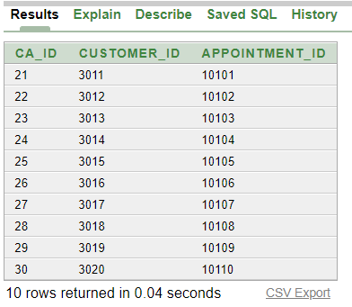

**(Pst_Used)**

INSERT INTO Pst_Used(pst_id,product_code,stockUsed_id)values(31,111111,80801);

INSERT INTO Pst_Used(pst_id,product_code,stockUsed_id)values(32,111112,80802);

INSERT INTO Pst_Used(pst_id,product_code,stockUsed_id)values(33,111113,80803);

INSERT INTO Pst_Used(pst_id,product_code,stockUsed_id)values(34,111114,80804);

INSERT INTO Pst_Used(pst_id,product_code,stockUsed_id)values(35,111115,80805);

INSERT INTO Pst_Used(pst_id,product_code,stockUsed_id)values(36,111116,80806);

INSERT INTO Pst_Used(pst_id,product_code,stockUsed_id)values(37,111117,80807);

INSERT INTO Pst_Used(pst_id,product_code,stockUsed_id)values(38,111118,80808);

INSERT INTO Pst_Used(pst_id,product_code,stockUsed_id)values(39,111119,80809);

INSERT INTO Pst_Used(pst_id,product_code,stockUsed_id)values(40,111120,80810);

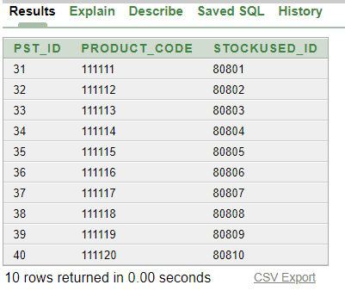

**(Pst_In)**

INSERT INTO Pst_In(pst_id,product_code,stockIn_id)values(31,111111,90901);

INSERT INTO Pst_In(pst_id,product_code,stockIn_id)values(32,111112,90902);

INSERT INTO Pst_In(pst_id,product_code,stockIn_id)values(33,111113,90903);

INSERT INTO Pst_In(pst_id,product_code,stockIn_id)values(34,111114,90904);

INSERT INTO Pst_In(pst_id,product_code,stockIn_id)values(35,111115,90905);

INSERT INTO Pst_In(pst_id,product_code,stockIn_id)values(36,111116,90906);

INSERT INTO Pst_In(pst_id,product_code,stockIn_id)values(37,111117,90907);

INSERT INTO Pst_In(pst_id,product_code,stockIn_id)values(38,111118,90908);

INSERT INTO Pst_In(pst_id,product_code,stockIn_id)values(39,111119,90909);

INSERT INTO Pst_In(pst_id,product_code,stockIn_id)values(40,111120,90910);

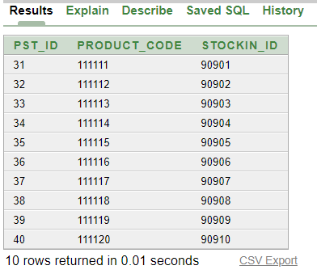

**SINGLE ROW FUNCTIONS**

1. Show all of the employees name and length of their name from Employee_Info table

• select emp_name"Employee Name",LENGTH(EMP_NAME)"LENGTH" from Employee_Info;

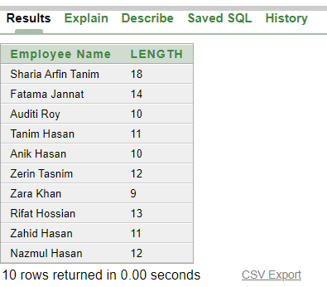

**GROUP FUNCTIONS**

1. Find out the payment id, maximum payment, minimum payment, average payment, count made by customer also sequence it by descending order? From Customer table.

• select payment_id, MAX(payment_amount),Min(payment_amount),avg(payment_amount),count (payment_amount) from Customer_Payment group by payment_id order by payment_id desc;

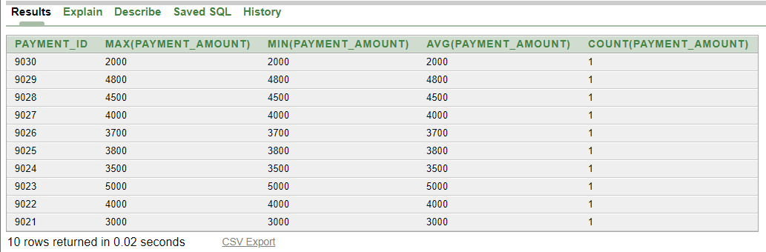

1. Display employee id, max stock in of quantity where max stock in quantity is less then 12.

select emp_id,max(stockin_qty) from stock_in group by emp_id having max(stockin_qty)<12

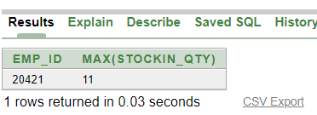

**Subqueries**

1. Display any name and appointment date of the customer whose appointment date same as Mehedi Hasan.

select customer_name, appointment_date from customer_info c,appointment_info a where c.emp_id=a.emp_id and appointment_date =(select appointment_date from customer_info,appointment_info where customer_info.emp_id=appointment_info.emp_id and customer_name='Mehedi Hasan');

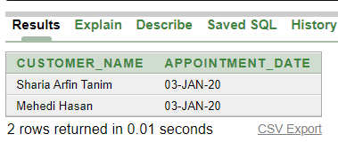

1. write a query to display customer id, name, address where address is not same as Rafsan Uddin.

select customer_id,customer_name,customer_address from customer_info where customer_address!=(select customer_address from customer_info where customer_name ='Rafsan Uddin');

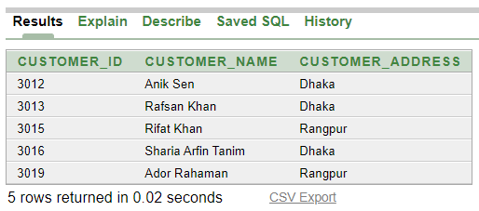

1. display service id, service name, service duration, what material use for price 90 to 3000.

select service_id,service_name,service_duration,service_material from service_info where service_price in(select service_price from service_info where service_price between 90 and 3000);

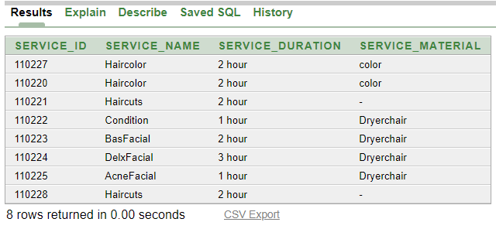

**Joining**

1. display all the employees id, name, gender, category, status where status is not manager.

select emp_id, emp_name, emp_gender, emp_category, emp_status from Employee_category e, Employee_info i where e.e_id = i.e_id and emp_status !='Manager';

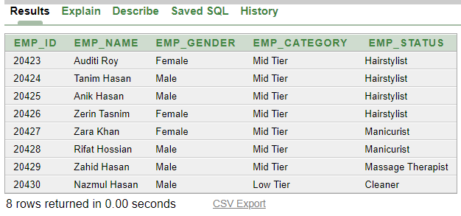

1. display customer name, email, appointment date who took appointment on the date 04-Jan-20.

select customer_name,customer_mail,appointment_date from Customer_Info c,Appointment_info a where a.emp_id=c.emp_id and appointment_date='04-JAN-20';

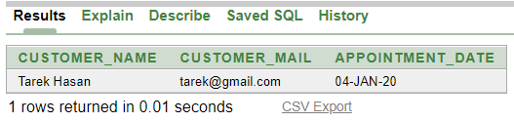

1. display all the product name, cost, stock in quantity, stock in date and stock out quantity, stock out date for the product code 111114.

select product_name, product_cost, stockIn_qty, stockIn_date ,stkused_qty, stkused_date from Product_info p,Stock_in i,Stock_used o where p.emp_id=i.emp_id and i.emp_id=o.emp_id and product_code=111114

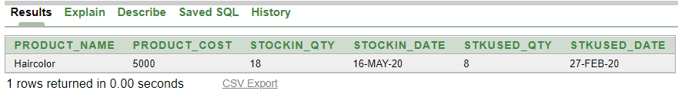

**View**

1. Create or replace view empview as

select emp_name,Appointment_date,customer_name from employee_info,Appointment_info,Customer_Info where employee_info.emp_id=Appointment_info.emp_id and Appointment_info.emp_id=Customer_Info.emp_id;

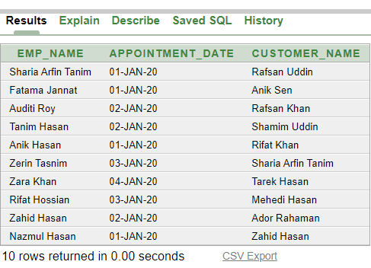

End